[Enter Activity name]
Kauri Dieback Activity Hygiene Plan

Activity Hygiene Plan
Activity: |  |  | Location:
Activity description
Provide a brief description of the activity:
Background information
This is a tool for planning activities in and around Kauri forests. This plan needs to be completed for each location an activity is performed. If you are carrying out an activity in a location for the first time it is recommended that you source background information if the activity is in or near a native forest environment or around Kauri. If you are familiar with the area, then you will have knowledge already on where Kauri might exist and how best to avoid Kauri Protection Areas (KPA’s). See below for definition.
Planning questions
Below and through this plan are questions aimed at helping you acquire background information as part of the planning process. It is important to consider these questions before you carry out your activity. If you have doubts about your answers it is advised to reconsider the location of your activity and seek further information and or assistance.
Will the activity be in a native forest? |  | Does the forest contain Kauri? |  |  | Do Kauri exist outside a forest environment?
Do I know what Kauri looks like? |  | Can I change the location of the activity to avoid Kauri? |  |  | Have I sourced background info on Kauri?
Can I avoid Kauri Protection Areas (KPA’s) during my activity (see below)? |  | Can I achieve strict hygiene on my activity if required? |  |  | What season is it? I need to avoid winter activities.
Do I have a hygiene kit with the right contents? |  | Do I understand where I need to use my hygiene kit? |  |  | Do I know my activity well enough to plan for protecting Kauri?
Kauri Protection Area (KPA)
The Kauri protection area (KPA) is the immediate vicinity of a tree which encompasses the trunk and the root system. This area is what needs protection. No soil movement is to occur in or out of this area. The total size of the KPA is determined by the number of Kauri present in the stand and where they exist on the slope. The perimeter of the KPA is 3 x the drip line of the individual tree or the most outlying tree in the stand. If the stand exists below the ridge line or spur then the KPA extends to the ridge or spur to protect the area above the stand from soil movement and possible introduction of the pathogen. The diagrams below help explain KPA’s.
KPA Diagram
Figure 1. Image of a Kauri drip line and root zone
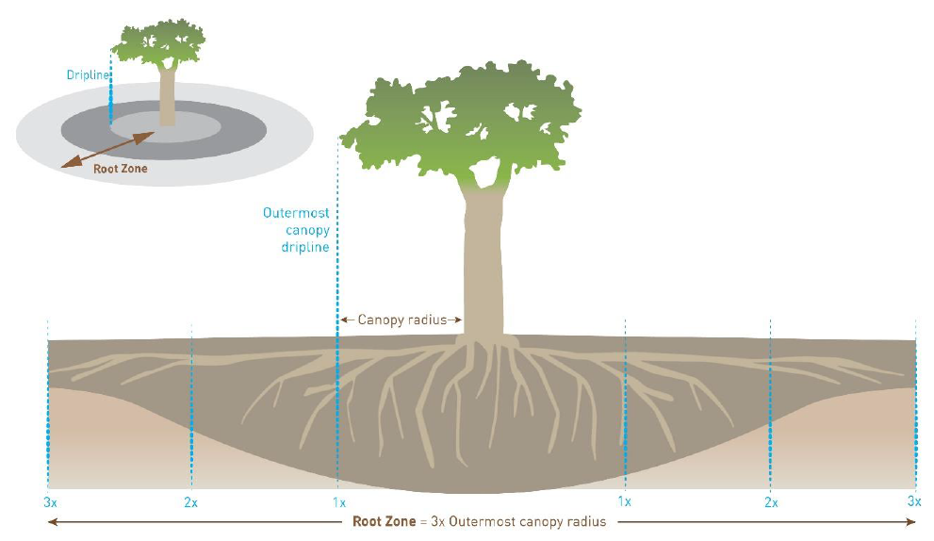

Activity hygiene recommendations
The best recommendations made for Kauri dieback are to avoid a forest or KPA altogether and change the location of the activity. Essential activities can be carried out but only if strict hygiene is applied and Kauri Protection Areas (KPA’s) are understood. The following table contains Kauri dieback vectors and how best to mitigate them during your activity. Answer yes or no in the box if they are applicable to your activity. Also, think about the travel to and from your activity.

Vector | Issue | Recommendation | Y/N
Vehicle Use | Movement of large amounts of soil/dirt | Vehicle movement is not recommended in forest blocks containing Kauri. Vehicles pose the biggest risks to dieback spread. This includes quads and motorbikes.
Hunting | Soil movement via animal and footwear | Hunters be aware of dog cleanliness. Always Avoid Kauri. Arrive clean, leave clean. If possible clean footwear every time you stop.
Trapping Activities | Movement of soil between stands or forests | Trappers should plan routes well and avoid Kauri. Traps and tools need to be clean. Always clean between forests. Often spurs provide ease of movement through the forest but also this is where Kauri exist
Foot Traffic | People moving soil on footwear | Avoid KPA’s at all costs. If activity involves being in a KPA then carry out hygiene on the edge, down slope of Kauri (see below).
Equipment, hand tools, animals etc | Any other activity not described above | Examples include digging tools, hand tools, equipment, horse hooves. Be mindful of all activities in relation to Kauri
Recommendations questions
Do you understand the recommendations for your activity?
Do you understand why they have been made?

Figure 2. Aerial view image of a KPA example

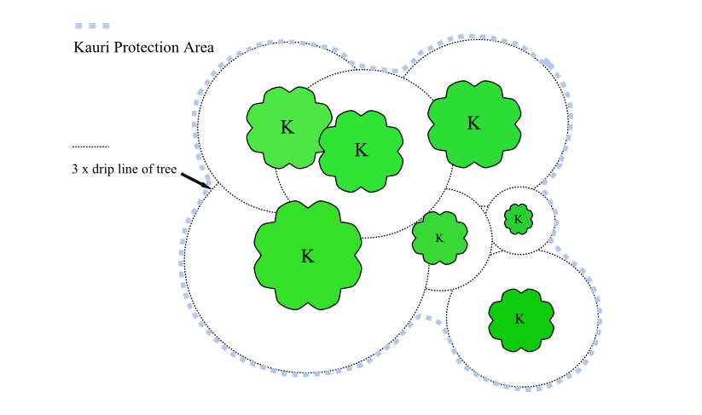

Figure 3. Aerial view example of a KPA with hygiene point and where to traverse past Kauri
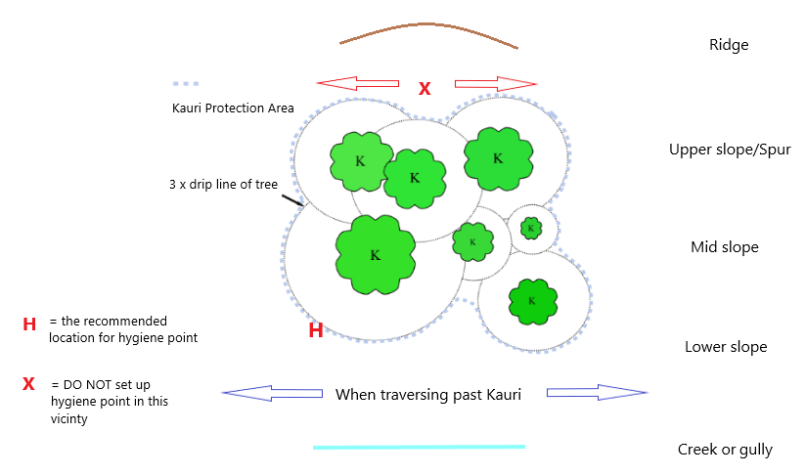

Figure 4. View of a KPA with hygiene point and where to traverse past Kauri
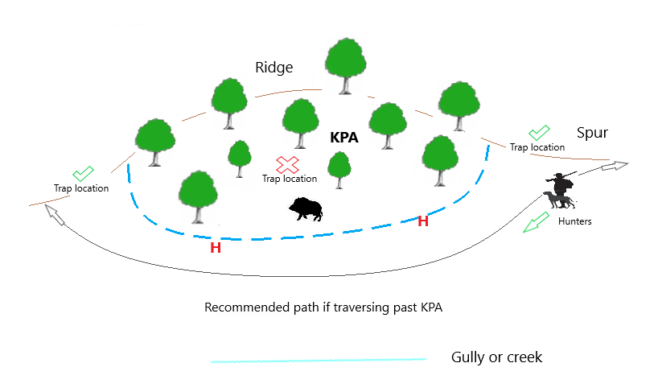
Note: Trappers are advised to avoid KPA’s for trap locations unless hygiene can be guaranteed. Hunters are advised not to enter KPA’s as hygiene is most difficult during this activity.

KPA questions
Do I understand the concept of KPA’s?
Do I understand the best practice for avoiding KPA’s?
Do all surfaces need to be free of dirt when entering a KPA?

Kauri Dieback Hygiene

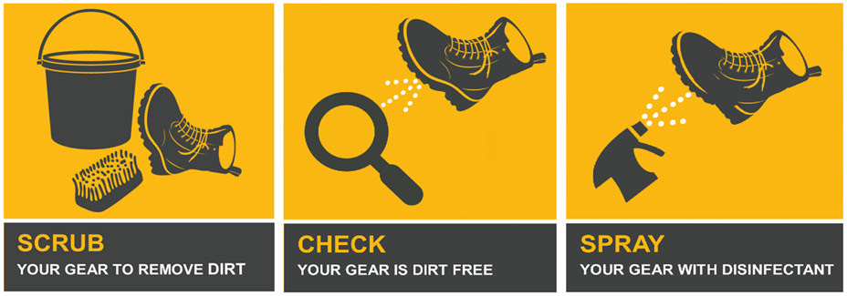
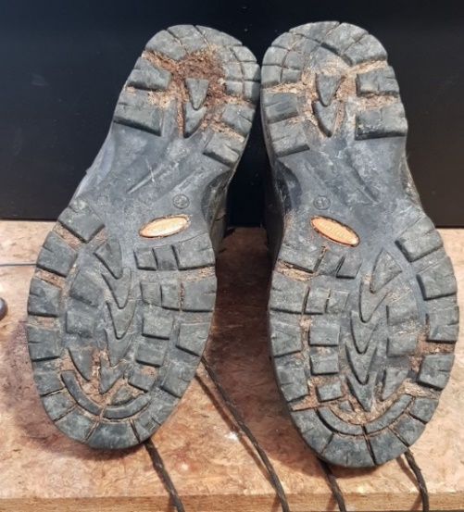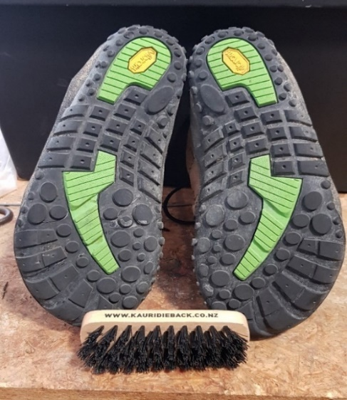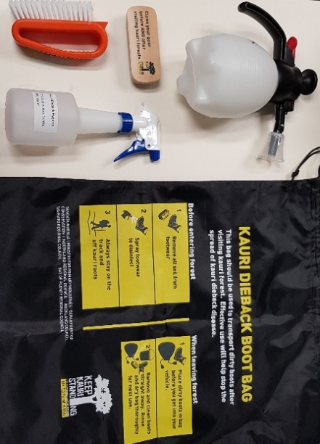
Dirty Boots Clean Boots Hygiene Kit Contents
Hygiene questions
Do I know the contents of a hygiene kit?
Do I understand the concept of hygiene for Kauri dieback?
Do I know what it takes to be hygienic in and around the forest and around KPA’s?
Available information
NRC has made information available to the public in the form of the Kauri dieback Hygiene Best Practice Guidelines document and information sheets for specific activities. These are accessible online via the NRC website (see link below) or by contacting NRC Kauri Dieback Team at kauridieback@nrc.govt.nz. NRC also conduct half day workshops for upskilling in Kauri dieback.
https://www.nrc.govt.nz/environment/weed-and-pest-control/biosecurity-programmes/kauri-dieback/
General advice
Human activities have the potential to spread infected material from one location to another over large distances. Until such point that more is known about the disease and its presence and movement through the soil, adhering to hygiene recommendations made in this activity hygiene plan is current best practice. In forested areas where Kauri exist all non-essential activities are not recommended. Entry in and around positive sample sites is also not permitted. It only takes the smallest amount of soil/dirt to move the pathogen to a new environment. Prevention is better than cure
Checklist
Fill out the section below and you’re ready to go!
Have I sourced info from NRC (documents) about kauri dieback? |  | Do I understand the importance of hygiene?
Do I understand the requirements of kauri dieback on my activity? |  | Do I know what it takes to be KD clean?
Where do I need to perform hygiene (list)? |  | What should be in my hygiene kit (list)?
At this point by reading the information available and answering the questions you will have a basic understanding of Kauri dieback disease, hygiene and knowledge on KPA’s and the importance of them. You now also know how to carry out your activity whilst protecting Kauri at the same time.

