High Risk
Vehicle and Machinery Hygiene Planner

Purpose
To provide guidelines for vehicle and machinery hygiene in and around kauri forests and KPA’s and other land use areas that are adjacent to kauri. Vehicles and machinery pose the greatest risk to pathogen spread via soil movement that any other vector. This document highlights the importance of vehicle and machinery hygiene, details the procedures required to mitigate this risk and informs people of best practice for vehicle and machine hygiene.
Legislative Requirements
Northland Regional Pest Management Plan – Diseases and Pathogens
Diseases and pathogens are a serious threat to Northlands native biodiversity, industry, cultural and social values. Diseases and pathogens require new and novel methods for control and furthermore a high level of community awareness especially for identifying and minimising vectors of spread.
Objectives  - For the duration of the pest plan prevent the spread of Kauri Dieback to reduce the impacts on biodiversity, cultural and economic values in Northland,  - Ensure coordination with other government agencies and the Department of Conservation to achieve the Pest Plan objectives |  | Aims  - To maintain a complete record of the full distribution of Kauri Dieback in Northland  - To increase public knowledge and skills, and encourage people to act to help reduce the spread of Kauri Dieback,  - To ensure that measures taken under the Pest Plan are complimentary to inter-regional and national approaches to Kauri Dieback,  - To utilise scientific and technological advancements to help reduce the spread of Kauri Dieback
Statutory Obligations
Under Sections 52 and 53 of the Biosecurity Act of 1993 no person can sell, propagate, breed distribute or otherwise spread any pest in this plan, or any unwanted organism. Section 53 also includes organisms which may contain or harbour a pest or unwanted organism. Not complying with section 52 and 53 is an offence under the Act and may result in a penalty, noted in section 157(1).
Vehicle and Machinery Soil Movement Risk Determination
The level of risk poses by the activity determines the checklist that must be completed as part of the planning process prior to the commencement of any job.
Activity | Vehicle or Machinery |  | Level of Risk
Trapping | Quad bikes
Landscaping/Lawn mowing | Lawn mower, ride on mower |  | Low
Arborist/Tree lopping (from road side) | Chain saw, mulcher, EWP
Hunting (with 4WD) | 4WD, cars, quads, trailers
Off roading/4WD-ing | Cars, 4WDs’, ATV’s, Quad bikes
Farm maintenance | Small/walk tractor and machinery |  | Moderate
Earthmoving (small jobs) | Mini digger/loader
Farming | Medium to large farm machinery plus trailers
Transport | Semi-trailers, low loaders |  | High
Earthmoving equipment (large jobs) | Loaders, excavators, dump trucks
Quarrying/Mining | Loaders, excavators, dump trucks
Obtaining important information
Prior to completing this planner, you will need a firm understanding of kauri dieback hygiene requirements. This information is available on the Northland Regional Council website. Please click the following links to download the relevant documents.
Kauri Dieback Hygiene Best Practice Guidelines: Kauri dieback hygiene best practice guideline (PDF, 1.1MB)
Vehicle and Machinery Hygiene Best Practice Guidelines: https://www.kauridieback.co.nz/media/1464/best-practice-guidelines-vehicles-and-heavy-machinery-hygiene.pdf
Kauri Dieback – Vehicle and Machinery Planner – High Risk
HIGH RISK
High risk definition: Large machinery and trucks and semi-trailers that are difficult to keep clean, regularly meet exposed dirt either through travelling to site or via the job or operation itself. This includes tracked machinery and those vehicles with many wheels. These jobs require the most complex level of hygiene because of the types vehicle or machinery involved. The ability to move dirt is high and frequent (earthmoving) and it is difficult to impossible to maintain a high level of hygiene whilst on site.
Seasonal onsideration
Winter operations are challenging for hygiene due to the amount of rainfall and the condition of the ground (muddy). Avoiding jobs around kauri altogether in winter and after rainfall events is strongly recommended. Low risk jobs carried out in winter could increase the risk category.
High risk job types
Circle or highlight the job type.
Earthmoving |  | Landscaping (major) |  |  | Utilities services |  |  | Forestry |  |  | Mining
Tree lopping |  | Timber harvesting (machine) |  |  | Vehicles (multiple) |  |  | Drilling |  |  | Farming (dirt moving)
Location or address of work site
Vehicles and Machinery Types
Diggers/Excavators |  | F/E loader |  |  | Bulldozer |  |  | Logging machinery |  |  | Drill rig
Scraper |  | Semi-trailer |  |  | Skid steer |  |  | Dump truck |  |  | Farm tractor
Plow (Farming) |  | Cement truck |  |  | Trucks (transport)
Background Information
This document is a tool for planning high risk jobs in and around Kauri and KPA’s. This checklist needs to be completed for each work location. If you are carrying out a job in a location for the first time it is recommended that you source background information if near a native forest environment or around Kauri. If you are familiar with the area, then you will have knowledge already on where Kauri might exist and how best to avoid Kauri Protection Areas (KPA’s).
Kauri Protection Areas (KPA’s)
The Kauri protection area (KPA) is the immediate vicinity of a tree which encompasses the trunk and the root system. This area is what needs protection. No soil movement is to occur in or out of this area. The total size of the KPA is determined by the number of Kauri present in the stand and where they exist on the slope. The perimeter of the KPA is 3 x the drip line of the individual tree or the most outlying tree in the stand. If the stand exists below the ridge line or spur then the KPA extends to the ridge or spur to protect the area above the stand from soil movement and possible introduction of the pathogen. See diagram below.
Kauri Protection Area (KPA)
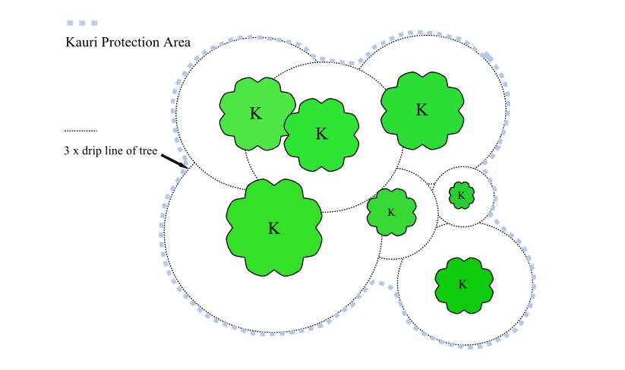
Planning Questions
The following are questions aimed at helping acquire background information as part of the planning process. It is important to consider these questions as part of job planning in order to protect kauri. If you have doubts about your answers it is advised to seek further information and or assistance. If you have read the documents in the links above (page 1) and are unsure please email the Kauri Dieback Team at NRC; kauridieback@nrc.govt.nz Answer Y/N to ALL questions.
Will the activity be in or around a native forest? |  |  |  | Does the forest contain Kauri? |  |  |  |  |  | Do Kauri exist outside a forest environment?
Do I know what Kauri looks like? |  |  |  | How many kauri exist? |  |  |  |  |  | Are kauri close to the work site?
Can I avoid Kauri Protection Areas (KPA’s) during my activity? |  |  |  | Do I understand the extent of the KPA, including taking slope into account? |  |  |  |  |  | Can I achieve strict hygiene on my activity if required?
High Risk Recommendations
The best recommendations made for kauri dieback are to avoid a forest or KPA altogether. This is achievable for recreational activities but not so for work and farming activities. Second to this is strict hygiene practices. Work activities can be carried out but only if strict hygiene is applied and Kauri Protection Areas (KPA’s) are understood. High risk activities are highly likely to move soil/dirt so recommendations around maintaining hygiene are in depth. The best practice around high-risk jobs is to clean the machine prior then drop it off clean at the work site. The machine must stay in the work area for the duration and must not move out of the designated work area to a location where additional hygiene would be required. Multiple machinery may be required to work in different areas rather than one crossing hygiene boundaries.
Vector | Recommendation |  |  |  |  |  |  |  |  |  |  | Initial
Machinery | Clean machinery at a depot or yard and and transport them clean on a clean truck to the work site. Transport dirty machinery away from site and clean back at depot or yard. Ensure material and dirt is contained during the transport process.
 | Use one machinery for each work site adjacent to a KPA. Do not cross hygiene boundaries between work areas with dirty machinery where KPA’s are present. See diagram 2 below.
 | For farming activities carry out hygiene at yard or shed. Consider slope in relation to forest block and potential soil movement activity.
Vehicles | Clean vehicles at a depot or yard and drive on sealed roads to the work site. Ensure vehicles only enter the work site past the hygiene point if necessary. Vehicle hygiene on site is achievable although difficult.
Footwear, Equipment | Don’t forget to maintain footwear, tools and equipment hygiene along with vehicles and machinery.
Understanding vehicle and machine hygiene
It is important to maintain a high level of hygiene regardless of the level of risk. It only takes a spec of dirt to spread the disease. Hygiene for vehicles and machinery means removal of all soil and vegetative matter from every surface that contacts the ground or is likely to become dirty. See below cleaning checklist.
Do I understand what it takes to clean a piece of machinery, vehicle or equipment?
Do I know where the vehicle and machinery will be cleaned prior to leaving for the work site (depot, home, car wash)?
Can machinery be transported to site in a hygienic manner? Delivered on a dirt-free trailer to site.
Treatment
Once most of the dirt and vegetated matter has been removed from surfaces the remaining particles of material or what’s left over from high pressure cleaning can treated with steam cleaning or hot water blasting or disinfectant. This is achieved by high pressure spraying surfaces with boiling water or steam. The remaining material is heated to a temperature that will kill the pathogen if it may be present in the material. This is highly recommended and should be carried out at a yard or depot. Alternatively, the same can be done with a disinfectant like Sterigene after high pressure cleaning is done.
Do you have access to steam cleaning or hot water blasting?
Where and how? TBC, see link
Do you have access to a disinfectant?
Note: Physical removal of dirt is key to preventing spread. Treatment should be considered if physical removal of dirt is not achievable. Treatment will not work on clumps of dirt because the chemical or heat won’t penetrate the mass.
Hygiene points
Hygiene point is the location on site where machinery can be unloaded into the work area, a visual inspection takes place on all vehicles and machinery and where small machinery and previously cleaned machinery may be wash down if required. This is the point where the hygiene station is located. Y/N
Do I know where to place hygiene points?
How many hygiene points required on site?
Note: The less hygiene points the better particularly where on site washing down is concerned. The recommendation is to arrive on site clean and avoid washing down where possible. Therefore, visual inspection or checks are carried out at this point.
Washdowns stations at hygiene points
Wash downs stations can be set up if required. This is for small machinery and vehicles that has been cleaned prior to arriving on site is easier to keep clean. Runoff may be permitted to drain into the surrounding environment provided it’s not in the vicinity of KPA’s (including up slope of). Otherwise contain run off or find a suitable location to wash down without containment (away from Kauri).
How many wash down stations are needed (one per hygiene point)?
If wash down station is needed does it meet requirements?
Clean on Entry or Exit
Vehicles or machinery may either need to be Clean on Entering site or Exiting depending on where KPA’s are in relation to the work site or access or sealed road back to depot or yard. Both Clean on Entry and Exit may be required. Once the location of KPA’s has been determined planning hygiene points and whether Clean on Entry or Exit is required can be completed.
Is Clean on Entry required? |  |  |  |  |  | Is Clean on Exit required?
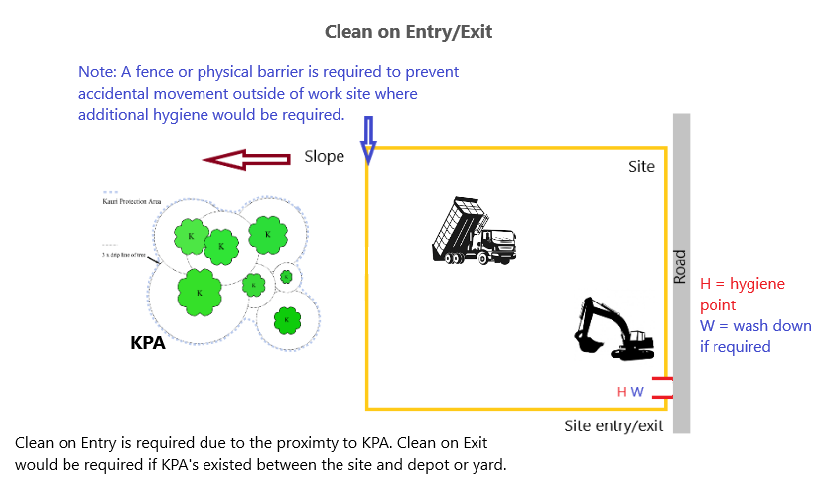
Run Off and Containment
If a wash down is required at a hygiene point on the work site, then it must first be determined where it will be set up in relation to KPA’s and if they or the environment will be impacted. First and foremost, vehicle and heavy machinery wash down on site is not recommended. Containment of run off material is difficult in this scenario. If this is to be carried out on site then run of must be contained. The amount of water required to successfully carry out on site wash down is high and allowing it to flow into the surrounding environment is not an option.
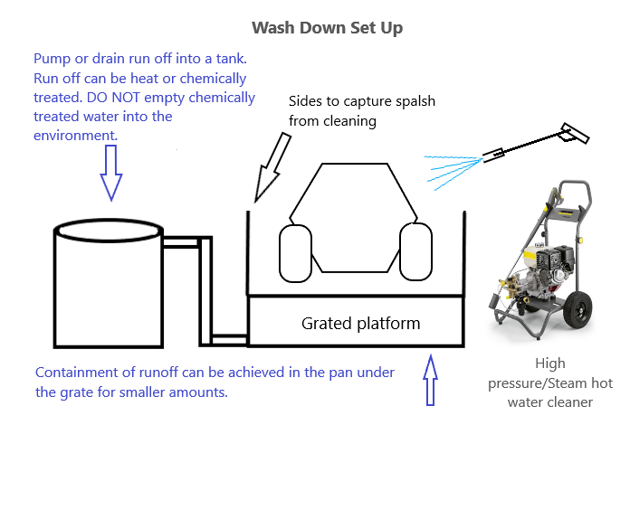
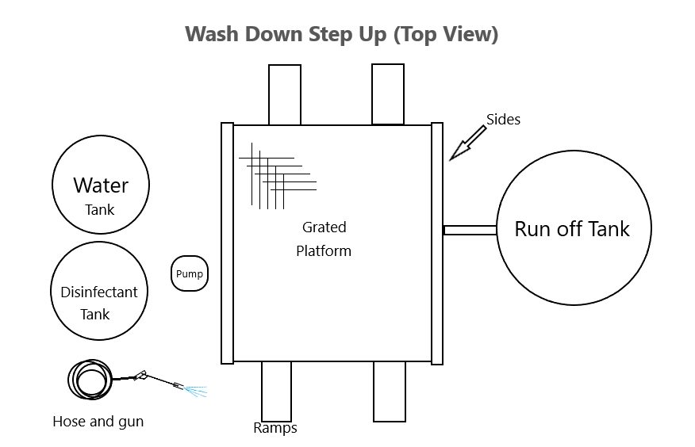
Machinery Wash Down Stations
Below are examples of wash down equipment for high risk vehicles and machinery. Note: a grate is required to keep equipment and machinery off the ground during the cleaning process. Always avoid contaminating the process by keeping the grate clean. Contain runoff under platform and pump to holding tank if necessary.
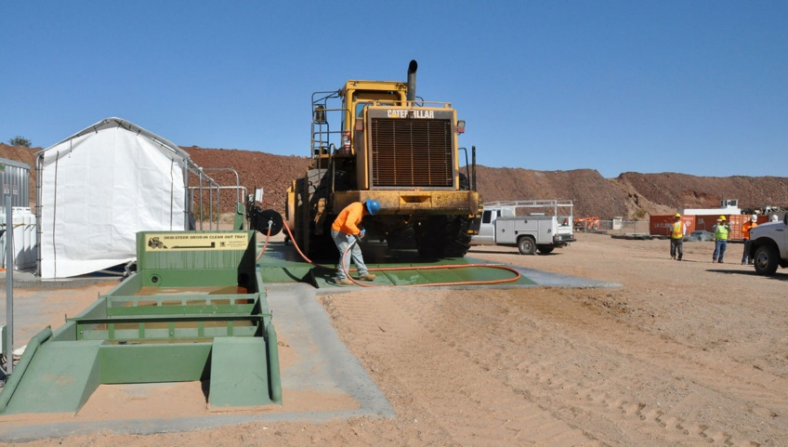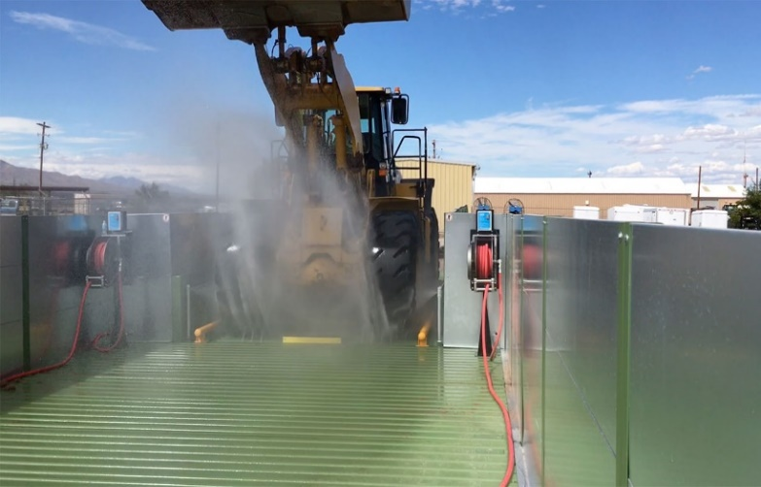
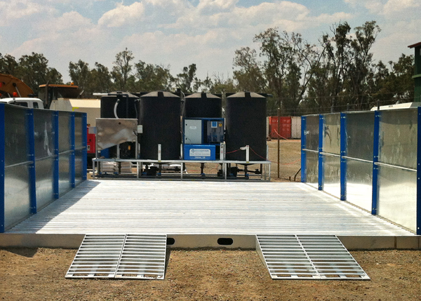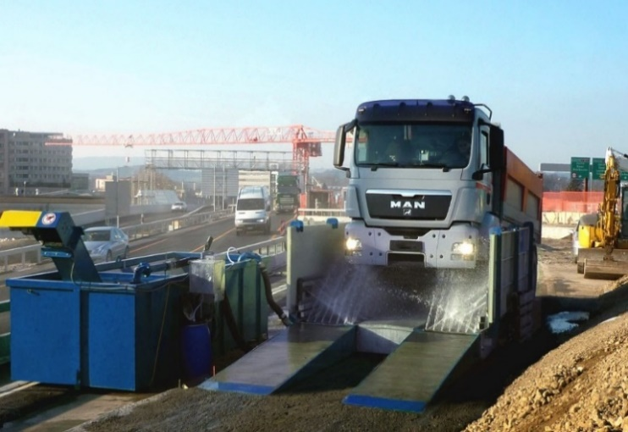
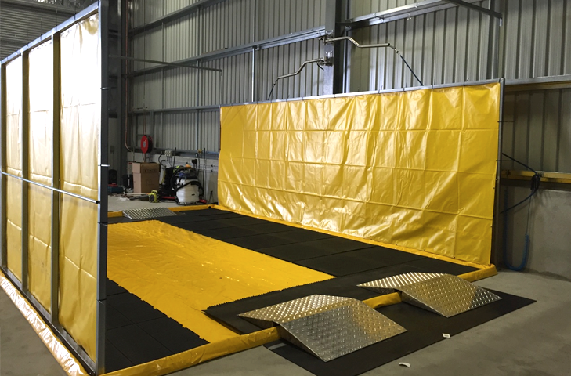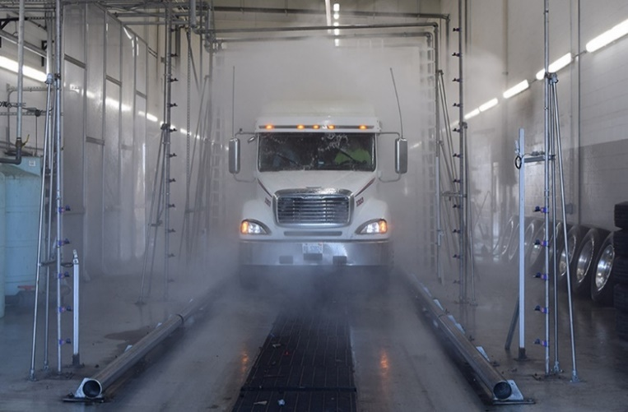
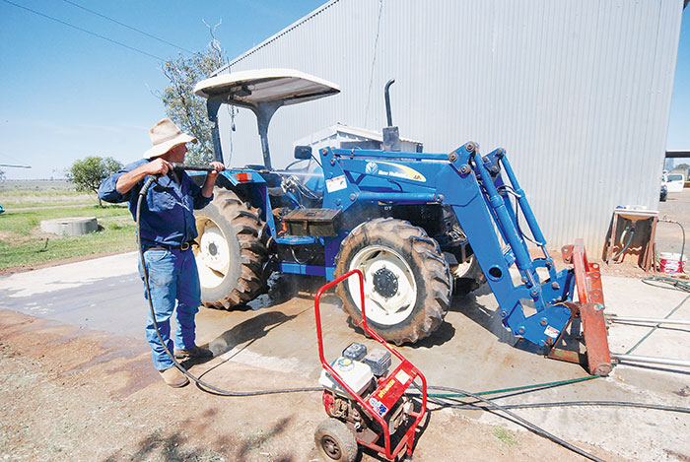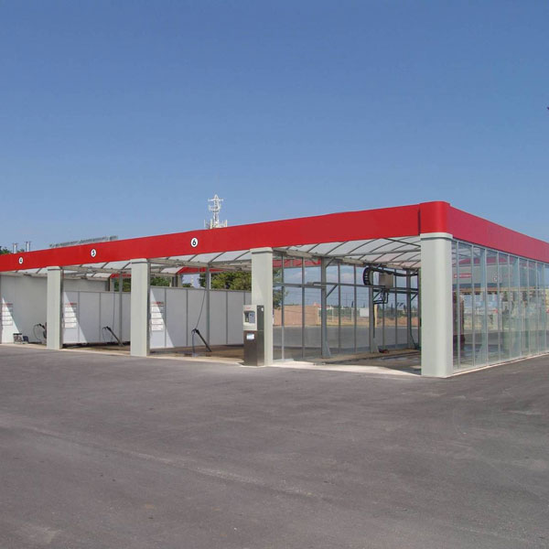

Standard of Hygiene
Consider all surfaces for vehicles that require cleaning. This not only includes those in direct contact with the ground but where dirt may end up through operation of the vehicle. See checklist below for consideration required for machinery.

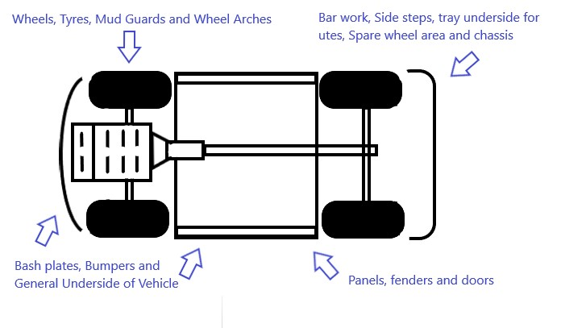
Diagrams of worksite
Include a drawing of your worksite in relation to KPA’s. Please consider kauri which may be outside of the immediate work site and down slope which would be at risk of any potential soil movement activity. Draw slope in relation to KPA’s. Mark hygiene points (H) and if wash down (W) will occur on site. The example below shows the level of detail required.

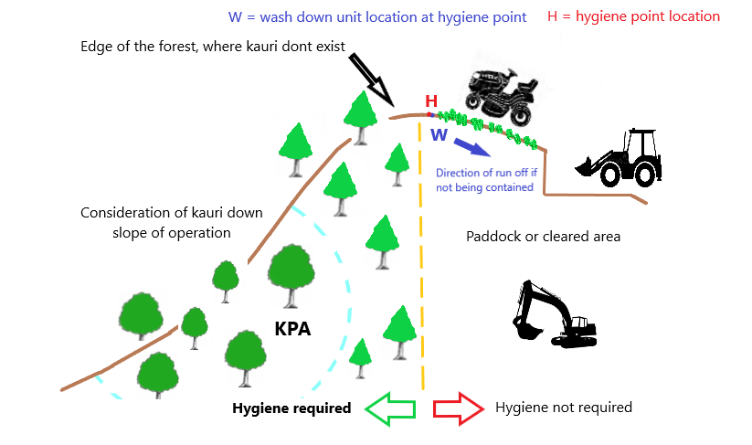

Below are possible scenarios operators may be faced with on the job regarding hygiene around kauri. They highlight the level of consideration and planning required.

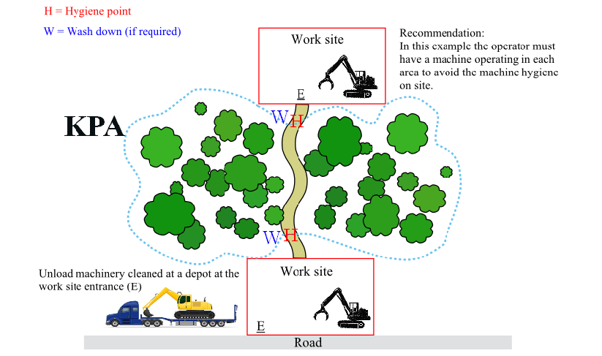

Note: Attach photographs of the site, hygiene point and surrounding area to this plan.
Sign off
Complete this section and sign prior to commencing job or activity
Have all the questions on the checklist been answered? |  |  |  |  |  |  | Are the requirements for protecting Kauri understood?
Do I understand vehicle and machinery hygiene requirements?
Name |  |  |  |  |  |  | Sign
Comments:

Vehicle and Medium to Large Machinery Hygiene Checklist
Registration/ID: |  | Make & Model: |  |  | Additional Vehicle Info:
Part |  | Type/Examples |  |  | N/A | Not Compliant | Compliant | Initial
Scrub bars |  | Front, Rear, Side
Fenders: |  | Front, Rear, Side
Fenders:
Radiator area
Belly plates /
Underside Protection
Bucket /blade /forks
Rippers
Suspension
Spare wheels
Wheels / tracks
Mud flaps
Flat sections |  | Esp. horizontal
Cupped sections
Chassis areas |  | H- or C- sections
Hinged Points: |  | Esp articulated areas e.g. FEL / Truck/ Crane/ Excavator arm
Leaks: |  | Motor, Transmission / Driveline / Hoses / Tanks / Hydraulics / Reservoirs
Leaks: |  | Excessive Grease
Spill kit(s) |  | (e.g. Hydrocarbon)
Water Tanks: |  | Potable /Treated /Untreated/ Capacity
Trailer(s) |  | Light/ Heavy/ Number/Capacity/Type
Cargo space
Clean down kit
Cabin; front |  | Floor and seats
Cabin; rear |  | Floor and seat
floormats
Treatment and Disinfectant
Treatment and disinfectant are an important part of the hygiene process. Not every spec of dirt can be removed during the washing process, but a spec is all you need to spread the disease. Treatment can be in the form of heat as described above. Temperatures of around 100C will suffice in killing the spores of the pathogen. Alternatively, on footwear, equipment and small vehicles or machinery a disinfectant can be used. This can either be 70/30 methylated spirits/water, 25% bleach (with main active ingredient) or Sterigene at 2%. The first 2 are more easily obtainable.
Signage
Work sites and hygiene points will need instructional signage. Signs are recommended to contain simple hygiene messages like scrub, check and spray are to be placed where visible on site. Ensure signs always remain clean and visible. NRC may be able to provide such signage or at least advise on content.
Sign Off
Assessor (Owner or Representative):
Mobile: |  |  |  | Email:
Signature | Name |  | Date & Time | Company/Agency

