Moderate Risk
Vehicle and Machinery Hygiene Planner

Purpose
To provide guidelines for vehicle and machinery hygiene in and around kauri forests and KPA’s and other land use areas that are adjacent to kauri. Vehicles and machinery pose the greatest risk to pathogen spread via soil movement that any other vector. This document highlights the importance of vehicle and machinery hygiene, details the procedures required to mitigate this risk and informs people of best practice for vehicle and machine hygiene.
Legislative Requirements
Northland Regional Pest Management Plan – Diseases and Pathogens
Diseases and pathogens are a serious threat to Northlands native biodiversity, industry, cultural and social values. Diseases and pathogens require new and novel methods for control and furthermore a high level of community awareness especially for identifying and minimising vectors of spread.
Objectives  - For the duration of the pest plan prevent the spread of Kauri Dieback to reduce the impacts on biodiversity, cultural and economic values in Northland,  - Ensure coordination with other government agencies and the Department of Conservation to achieve the Pest Plan objectives |  |  |  |  |  |  | Aims  - To maintain a complete record of the full distribution of Kauri Dieback in Northland  - To increase public knowledge and skills, and encourage people to take action to help reduce the spread of Kauri Dieback,  - To ensure that measures taken under the Pest Plan are complimentary to inter-regional and national approaches to Kauri Dieback,  - To utilise scientific and technological advancements to help reduce the spread of Kauri Dieback
Statutory Obligations
Under Sections 52 and 53 of the Biosecurity Act of 1993 no person can sell, propagate, breed distribute or otherwise spread any pest in this plan, or any unwanted organism. Section 53 also includes organisms which may contain or harbour a pest or unwanted organism. Not complying with section 52 and 53 is an offence under the Act and may result in a penalty, noted in section 157(1).
Vehicle and Machinery Soil Movement Risk Determination
The level of risk poses by the activity determines the checklist that must be completed as part of the planning process prior to the commencement of any job.
Activity |  |  |  |  | Vehicle or Machinery |  |  |  |  |  |  |  |  |  |  | Level of Risk
Trapping |  |  |  |  | Quad bikes
Landscaping/Lawn mowing |  |  |  |  | Lawn mower, ride on mower |  |  |  |  |  |  |  |  |  |  | Low
Arborist/Tree lopping (from road side) |  |  |  |  | Chain saw, mulcher, EWP
Hunting (with 4WD) |  |  |  |  | 4WD, cars, quads, trailers
Off roading/4WD-ing |  |  |  |  | Cars, 4WDs’, ATV’s, Quad bikes
Farm maintenance |  |  |  |  | Small/walk tractor and machinery |  |  |  |  |  |  |  |  |  |  | Moderate
Earthmoving (small jobs) |  |  |  |  | Mini digger/loader
Farming |  |  |  |  | Medium to large farm machinery plus trailers
Transport |  |  |  |  | Semi-trailers, low loaders |  |  |  |  |  |  |  |  |  |  | High
Earthmoving equipment (large jobs) |  |  |  |  | Loaders, excavators, dump trucks
Quarrying/Mining |  |  |  |  | Loaders, excavators, dump trucks
Obtaining important information
Prior to completing this planner, you will need a firm understanding of kauri dieback hygiene requirements. This information is available on the Northland Regional Council website. Please click the following links to download relevant documents.
Forest hygiene: Kauri dieback forest hygiene procedure (PDF, 1.65MB) Update on NRC website
Vehicle and Machinery Hygiene Best Practice Guidelines: Add link from Kauri dieback website

Vehicle and Machine Hygiene Planning Checklist – Moderate Risk
MODERATE RISK
Moderate risk definition: Medium size machinery all cars, 4WD’s and off road vehicles have moderate risk of spreading soil or dirt based on size and ability to spread or carry dirt. This means an increased likelihood of moving dirt due to the type of operation or job. These jobs require a more complex level of hygiene because of the types vehicle or machinery involved. It’s more likely that vehicles and machinery will interact with bare earth and unkept surfaces.
Seasonal consideration
Winter operations are challenging for hygiene due to the amount of rainfall and the condition of the ground (muddy). Avoiding jobs around kauri altogether in winter and after rainfall events is strongly recommended. Medium risk jobs carried out in winter will increase the risk category.
Low risk activity types
Is your activity one of the following low risk activities (circle/highlight). If not reassess the level of risk posed by the activity or job.
Hunting (4WD’s) |  | Farm maintenance |  |  |  | 4WDing |  |  |  |  | Fencing contractor |  |  | Trail bike riding
Off roading |  | Small earthworks
Location or address of activity
Vehicles and Machinery Types
Cars/4WD’s |  | Side by Side ATV |  |  |  | Small tractor |  |  |  |  | Farm quad |  |  |  | ATV
Trail bike |  | Walking tractor |  |  |  | Vehicle Trailer |  |  |  |  | Stand on digger/loader |  |  |  | Post hole digger
Background Information
This checklist is a tool for planning moderate risk activities in and around Kauri and KPA’s. This checklist needs to be completed for each work location. If you are carrying out a job in a location for the first time it is recommended that you source background information if near a native forest environment or around Kauri. If you are familiar with the area, then you will have knowledge already on where Kauri might exist and how best to avoid Kauri Protection Areas (KPA’s).
Kauri Protection Areas (KPA’s)
The Kauri protection area (KPA) is the immediate vicinity of a tree which encompasses the trunk and the root system. This area is what needs protection. No soil movement is to occur in or out of this area. The total size of the KPA is determined by the number of Kauri present in the stand and where they exist on the slope. The perimeter of the KPA is 3 x the drip line of the individual tree or the most outlying tree in the stand. If the stand exists below the ridge line or spur then the KPA extends to the ridge or spur to protect the area above the stand from soil movement and possible introduction of the pathogen See diagram below.
Kauri Protection Area (KPA)
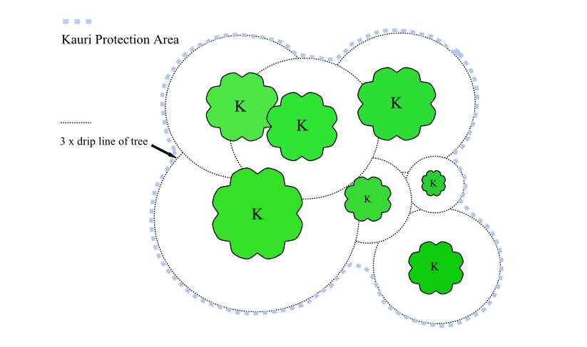
Planning Questions
The following are questions aimed at helping acquire background information as part of the planning process. It is important to consider these questions as part of job planning in order to protect kauri. If you have doubts about your answers it is advised to seek further information and or assistance. If you have read the documents in the links above (page 1) and are unsure please email the Kauri Dieback Team at NRC; kauridieback@nrc.govt.nz Answer Y/N to ALL questions.
Will the activity be in or around a native forest? |  |  |  | Does the forest contain Kauri? |  |  |  |  |  |  |  |  | Do Kauri exist outside a forest environment?
Do I know what Kauri looks like? |  |  |  | How many kauri exist? |  |  |  |  |  |  |  |  | How far are kauri from the work site?
Do they exist up slope, downslope or across? |  |  |  | Can I avoid Kauri Protection Areas (KPA’s) during my activity? |  |  |  |  |  |  |  |  | Can I achieve strict hygiene on my activity if required?
Moderate Risk Recommendations
The best recommendations made for kauri dieback are to avoid a forest or KPA altogether. This is achievable for recreational activities but not so for work and farming activities. Second to this is strict hygiene practices. Work activities can be carried out but only if strict hygiene is applied and Kauri Protection Areas (KPA’s) are understood. Moderate risk activities present a higher potential for moving dirt so recommendations around maintaining hygiene require a higher level of attention. (Initial each box to acknowledge mitigation is understood and actions completed).
Vector | Recommendation |  |  |  |  |  |  |  |  |  |  |  |  |  |  |  |  | Initial
Vehicle and Quad | Clean vehicles and trailers at a depot, home or car wash and don’t drive onto muddy tracks or ground around work site. Select location to park vehicles and access on foot to reduce frequency of cleaning down.
Small Machinery | Clean small machinery that comes contact with the ground at home or depot. Load onto clean trailer. Avoid bare earth or muddy ground around work site. Clean on site as required.
Equipment | Clean post hole diggers, tractor attachments, mini digger/loader and other motorised equipment prior to each job. Clean them between sites if KPA in the vicinity.
Footwear and Equipment | Don’t forget to maintain footwear, tools and equipment hygiene along with vehicles and machinery.
Understanding vehicle and machine hygiene
Medium risk activities mean there is less of a chance of moving soil. However, it is still important to maintain a high level of hygiene regardless of the level of risk. It only takes a spec of dirt to spread the disease. Hygiene for vehicles and machinery means removal of all soil and vegetative matter from every surface that contacts the ground or is likely to become dirty. See checklist below.
Do I understand what it takes to clean a piece of machinery, vehicle or equipment?
Do I know where the vehicle and machinery will be cleaned prior to leaving for the work site (depot, home, car wash)?
Have I filled out the vehicle and machinery cleaning checklist?
Can machinery be transported to site in a hygienic manner? Delivered on a dirt-free trailer to site.
Treatment
Once most of the dirt and vegetated matter has been removed from surfaces the remaining particles of material or what’s left over from high pressure cleaning can treated with steam cleaning or hot water blasting or disinfectant. This is achieved by high pressure spraying surfaces with boiling water or steam. The remaining material is heated to a temperature that will kill the pathogen if it may be present in the material. This is highly recommended and should be carried out at a yard or depot. Alternatively, the same can be done with a disinfectant like Sterigene after high pressure cleaning is done.
Do you have access to steam cleaning or hot water blasting?
Where and how? TBC, see link
Do you have access to a disinfectant?
Note: Physical removal of dirt is key to preventing spread. Treatment should be considered if physical removal of dirt is not achievable. Treatment will not work on clumps of dirt because the chemical or heat won’t penetrate the mass.
Hygiene points
Hygiene point is the location on site where machinery can be unloaded into the work area, a visual inspection takes place on all vehicles and machinery and where small machinery and previously cleaned machinery may be wash down if required. This is the point where the hygiene station is located. Y/N
Do I know where to place hygiene points?
How many hygiene points required on site?
Note: The less hygiene points the better particularly where on site washing down is concerned. The recommendation is to arrive on site clean and avoid washing down where possible. Therefore, visual inspection or checks are carried out at this point.
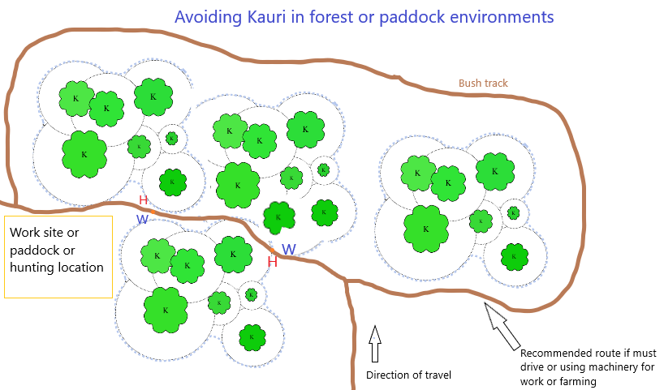
Wash Down Station
Wash downs stations can be set up if required as small machinery and quads that has been cleaned prior to arriving on site is easier to keep clean. Runoff may be permitted to drain into the surrounding environment provided it’s not in the vicinity of KPA’s (including up slope of). If in the vicinity of KPA’s including upslope run off must be contained. See below.
How many wash down stations are required (one per hygiene point)?
If wash down station is needed does it meet requirements?
Will run off material be contained (see recommendations above)?
Clean on Entry or Exit
Vehicles or machinery may either need to be Clean on Entering site or Exiting depending on where KPA’s are in relation to the work site or access or sealed road back to depot or yard. Both Clean on Entry and Exit may be required. Once the location of KPA’s has been determined planning hygiene points and whether Clean on Entry or Exit is required can be completed. Wash down is required on site for Clean on Exit’s.
Is Clean on Entry required? |  |  |  |  |  |  |  |  | Is Clean on Exit required?
Run off and Containment
If a wash down is required at a hygiene point on the work site, then it must first be determined where it will be set up in relation to KPA’s and if they or the environment will be impacted. With Low Risk, the size of machinery is small and depending on the scenario the amount of run off from on site washing down will also be low. This is permitted to drain into the surrounding environment only if it will not impact KPA’s (down slope is acceptable, as is across slope at distance) and the surrounding environment through erosion and flooding. Run off is recommended to be contained and can be done so in the following way:

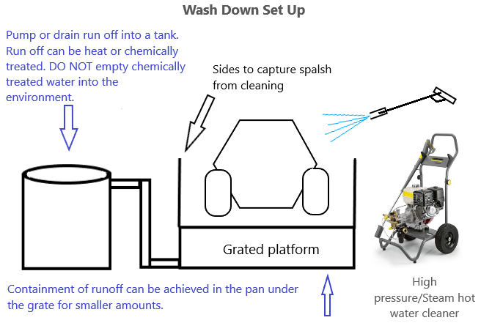
Diagram 1.
Below are examples of wash down equipment for medium risk vehicles and machinery. Note: a grate is required to keep equipment and machinery off the ground during the cleaning process. Always avoid contaminating the process by keeping the grate clean.

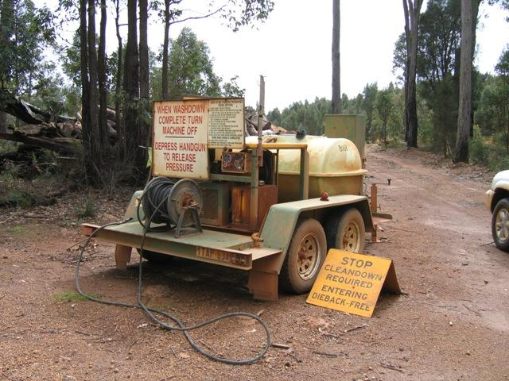
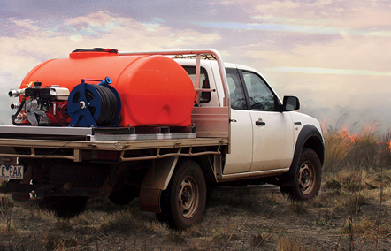
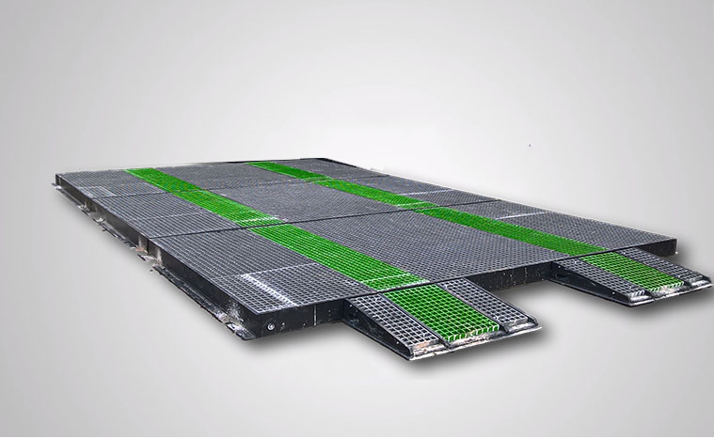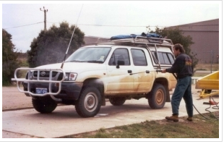

Consider all surfaces for vehicles that require cleaning. This not only includes those in direct contact with the ground but where dirt may end up through operation of the vehicle. See checklist below for consideration required for machinery.
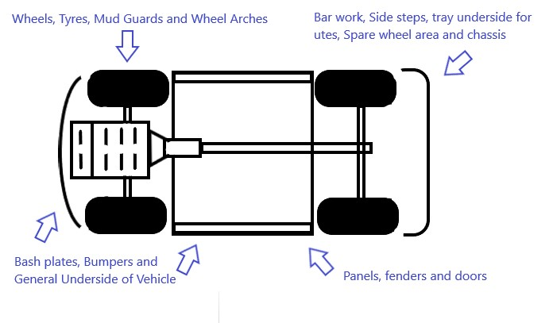
Diagram 2. Bottom view
Location of KPA’s to work place
Please consider kauri which may be outside of the immediate work site and down slope which would be at risk of any potential soil movement activity. Draw slope in relation to KPA’s. Mark hygiene points (H) and if wash down (W) will occur on site. Attach separate diagram if required.
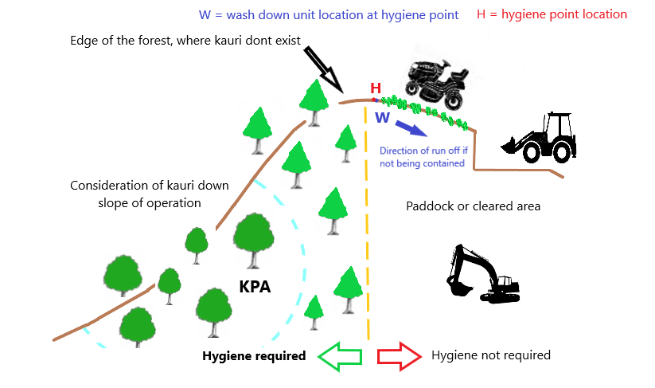
Diagram 3. Side view
Attach photographs of the site, hygiene point and surrounding area if possible.
Sign off
Complete this section and sign prior to commencing job or activity
Have all the questions on the checklist been answered? |  |  |  |  |  |  |  | Are the requirements for protecting Kauri understood?
Name |  |  |  |  |  |  |  |  |  | Sign
Comments:

Small Vehicle and Machinery Hygiene Checklist
Registration/ID: |  | Make & Model: |  |  | Additional Vehicle Info:
Part |  | Comments |  |  | N/A | Not Compliant | Compliant | Initial
Quad Bike/ Ride on Mower/Quad Trailer/Lawn Mower
Wheels and tyres |  | Front, Rear
Mud guards |  | Front, rear
Axles |  | Front, Rear
Underside Protection
Foot wells |  | Grates, peddles
Exhaust
Engine bay |  | Below engine on push mower
Suspension |  | Springs
Frame
Cutting blades
Blade protector
Jockey wheels
Attachments |  | Clippings bag, bin
Vehicle Trailer/Chipper
Wheels and Tyres
Underside
Axle and suspension
Jockey wheel
Mulcher/Chainsaw/Motorised or powered garden tools
Base or underside
Chain and bar |  | Chainsaw
Wheels |  | Mulcher
Frame
Cutting blades |  | Hedge trimmer or similar
Shaft and head |  | Weed wacker/whipper snipper/edge trimmer
Other
Treatment and Disinfectant

Treatment and disinfectant are an important part of the hygiene process. Not every spec of dirt can be removed during the washing process, but a spec is all you need to spread the disease. Treatment can be in the form of heat as described above. Temperatures of around 100C will suffice in killing the spores of the pathogen. Alternatively, on footwear, equipment and small vehicles or machinery a disinfectant can be used. This can either be 70/30 methylated spirits/water, 25% bleach (with main active ingredient) or Sterigene at 2%. The first 2 are more easily obtainable.
Signage
Work sites and hygiene points will need instructional signage. Signs are recommended to contain simple hygiene messages like scrub, check and spray are to be placed where visible on site. Ensure signs always remain clean and visible. NRC may be able to provide such signage or at least advise on content.
Sign Off
Assessor (Owner or Representative):
Contact Details | Mobile: |  |  | Email:
Signature | Name |  | Date & Time | Company/Agency

